Transitions Skills and Strategies
Mindset student activities:
Session instructions

Tutors should ask the students to read the worksheet to help them to gain an understanding of the impact of learning on the human brain. They have been told that the self-theory of intelligence is sometimes referred to as Mindset.

It is important that the students are aware of the research which is referenced in the activity and suggests that it is possible to have a fixed or a growth mindset (Dweck 2006). It is stated that people who have a growth mindset believe that their most basic abilities can be developed through dedication, practice and hard work. It follows that if students can adopt this approach they will accept that, as learners, their brain and their current skills can be developed. The alternative approach of a fixed mindset can inhibit student performance in higher education.

Once they read the information at the start of the activity, the students have been asked to look at the following statements and choose if they represent a growth or a fixed mindset. The answers have been added to the second column. This activity will increase awareness of the difference between a fixed and a growth mindset when applied to statements that are common in an academic environment.

I have never been good at maths | fixed mindset
With a bit more effort my essay writing would improve | growth mindset
If I work harder next time I will pass the re-sit | growth mindset
I'm not clever enough to understand this | fixed mindset
Plan B will be better than Plan A | growth mindset
I give up too early | fixed mindset
Deadlines help me to focus | growth mindset
This module is too hard | fixed mindset
I should never have started this course | fixed mindset
I can learn from my mistakes | growth mindset

In the next part of the activity, students have been asked to consider the following fixed mindset statements and by apply the 'change mindset process' to provide alternative growth mindset statements for each. The process is:

- hear the fixed mindset voice
- realise that you have a choice
- listen to the alternative growth mindset voice
- act on the mindset voice.

Some suggested alternative statements are provided in the second column for you to discuss with students.

Fixed mindset statements | Alternative growth mindset statements
I can't write essays | I have an opportunity to learn more about how to write a good essay.
The other students understand this better | Am I missing something? If I speak to the other students, I can find out what I need to know.
The lecturer gave me too low a mark | I need to get feedback from the lecturer so I can work harder and improve my mark.
This is the best I can do | I know that I can work harder and do better than this.
It wasn't my fault that I missed the deadline | I need to take responsibility for missing the deadline and make sure it does not happen again.
There is too much work to do to pass | It's time to make a study plan and put more time into my studies so that I pass.
I never sleep well the night before an exam | I'm going to speak to my tutor to discuss strategies to help me relax under pressure.
I'm aiming for the pass mark of 40% | 40% is well below what I know I can achieve if I work hard enough.
I ignore feedback when I get coursework back | Feedback can really help me to look for areas to improve my future coursework.
There is no point going to the exam, I will just wait and do the re-sit | I might pick up some tips from attending the exam or do better than I expect and pass.
Attending the revision tutorial would be a waste of time | The revision tutorial will give me some extra guidance to help me focus my study.
I lose an hour a day travelling to university | I can catch up with some rest or read my notes when I am travelling to university.
It's hard to get in on time for the 9am lecture | The discipline of getting to 9am lectures is giving me good experience for future employment.
I hate group work. Other people hold me back | Group work gives me a chance to develop leadership skills.
Only my core modules are interesting | The non-core modules are broadening my knowledge of other subject disciplines.

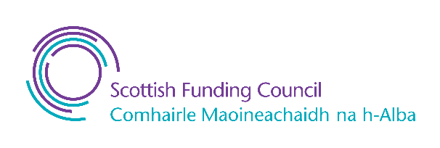Published by QAA, and produced by the sector and QAA Scotland, this resource has been commissioned by the Scottish Funding Council to support its duty to secure provision for assessing and enhancing the quality of fundable further and higher education provision.

Published - 9 January 2023
© The Quality Assurance Agency for Higher Education 2023
Registered charity numbers 1062746 and SC037786
www.enhancementthemes.ac.uk

