Transitions Skills and Strategies
Developing my self-belief
Consider a time when you have given a presentation, worked on a group project, introduced yourself to a student you had never met before or some similar task or learning event. Write below some details about the event or task that you have chosen.

Ask yourself the question, how confident did you feel before or soon after you started this task or learning event and write this down in the box below.

If you had to undertake a similar task or learning event, starting with small and short-term achievable goals, write down some ideas that you have for how you could be more confident and achieve more than you did before. Take as many small steps as you need. Later you can give yourself more difficult and longer-term goals.

In future, when you are feeling stressed, try to view the event/task/situation that is contributing to how you are feeling as a challenge. By not thinking of it as a threat, you are more likely to overcome it.

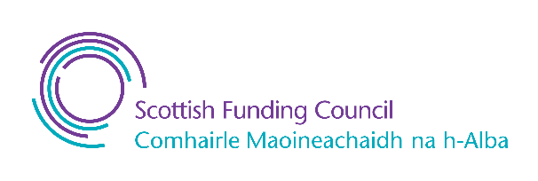Published by QAA, and produced by the sector and QAA Scotland, this resource has been commissioned by the Scottish Funding Council to support its duty to secure provision for assessing and enhancing the quality of fundable further and higher education provision.

Published - 9 January 2023
© The Quality Assurance Agency for Higher Education 2023
Registered charity numbers 1062746 and SC037786
www.enhancementthemes.ac.uk

